**PYTHON ASSIGNMENT**

Convert JSON String to Dictionary Python

import json

jsonString = '{ "id": 121, "name": "Naveen", "course": "MERN Stack"}'

student_details = json.loads(jsonString)

print(student_details)

print(student_details['name'])

print(student_details['course'])

Output

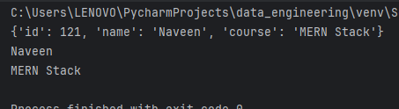

Convert JSON File to Python Object

import json

# Opening JSON file

with open('data.json') as json_file:

data = json.load(json_file)

print("Type:", type(data))

print("\nPeople1:", data['people1'])

print("\nPeople2:", data['people2'])

Output

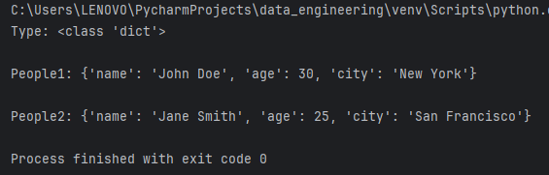

Convert Nested JSON Object to Dictionary

import json

# Opening JSON file

with open('data.json') as json_file:

data = json.load(json_file)

print(data['people1'][0])

print("\nPrinting nested dictionary as a key-value pair\n")

for i in data['people1']:

print("Name:", i['name'])

print("Website:", i['website'])

print("From:", i['from'])

print()

Output

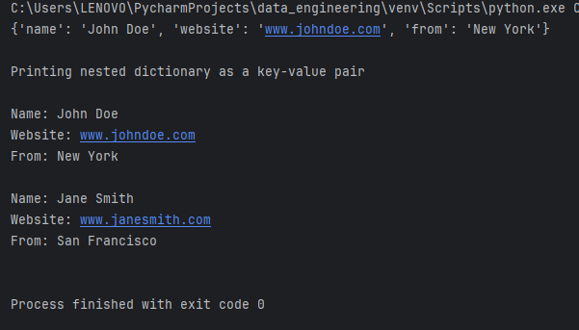

Convert JSON String to Dictionary in Python

import json

# JSON string

json_string = '{"Name": "Suezen", "age": 23, "Course": "DSA"}'

# Convert JSON string to dictionary

json_dict = json.loads(json_string)

print(json_dict)

Output

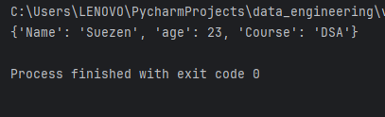

Python Parse JSON String

import json

# JSON string

employee = '{"id":"09", "name": "Nitin", "department":"Finance"}'

# Convert string to Python dict

employee_dict = json.loads(employee)

print(employee_dict)

print(employee_dict['name'])

Output

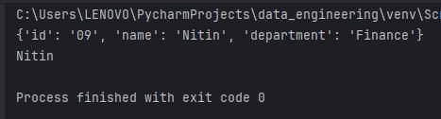

Python read JSON file

import json

# Opening JSON file

f = open('data.json', )

data = json.load(f)

for i in data['emp_details']:

print(i)

# Closing file

f.close()

Output

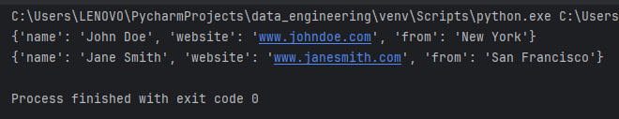

Convert Python Dict to JSON

import json

dictionary = {

"id": "04",

"name": "sunil",

"department": "HR"

}

json_object = json.dumps(dictionary, indent=4)

print(json_object)

Output

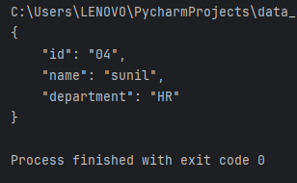

Writing JSON to a file in Python

import json

dictionary = {

"name": "sathiyajith",

"rollno": 56,

"cgpa": 8.6,

"phonenumber": "9976770500"

}

with open("sample.json", "w") as outfile:

json.dump(dictionary, outfile)

Python Pretty Print JSON

import json

# JSON string

employee = '{"id":"09", "name": "Nitin", "department":"Finance"}'

employee_dict = json.loads(employee)

print(json.dumps(employee_dict, indent=4, sort_keys=True))

Output

